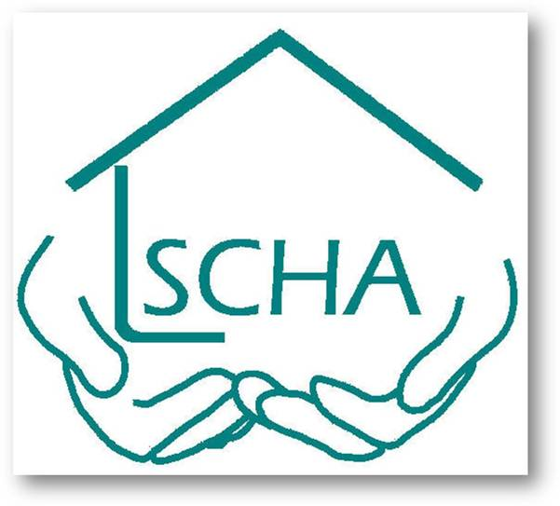

SOLIHULL CARE HOUSING ASSOCIATION LTD

Complaints Policy and Procedure

Document Title | Complaints Policy and Procedure
Version | Final v1.0
Release Date | May 2023
Review Date | May 2026 and yearly thereafter
Submission by | Gurdev Singh – General Manager
Document Type | Policy
Board Approval Sign Off Date | Board Approved 06 September 2024

Introduction

Solihull Care Housing Association (SCHA) is committed to providing high standards of service and housing related support to all its residents.

1.0 Scope

This policy sets out SCHA’s approach to managing complaints and service requests.
- The policy applies to all residents of SCHA, those on SCHA’s waiting list for accommodation, SCHA residents who terminated their tenancy within 12 months.
- Confidentiality and data protection apply to the complaints process, SCHA will not share personal, or property information gathered as part of the complaint investigation with any third party who is not entitled to receive it, in line with data protection legislation.
- Complaints made by other parties will be responded to outside of the complaints policy.

2.0 Aims & Objectives

SCHA strives to deliver high-quality services to residents, every effort is made to get things right first time but sometimes this does not happen.

The policy sets out how SCHA will respond to complaints.
- Inclusive - The policy strives to be inclusive and allows for all SCHA residents to have access to the complaints process, and to be heard and treated fairly.
- Learning - Each complaint or service request is an opportunity to investigate concerns, correct wrongs, to make necessary changes and if appropriate apologise and learn importantly from mistakes.
- Transparency – SCHA understands having a clear, resident-friendly complaints policy is the best and healthiest way to build strong professional relationships.

Key Terms and Definitions

Formal Complaint: To ensure consistency and understanding SCHA defines a complaint as:

“An expression of dissatisfaction, however made, about the standard of service, actions or lack of actions by the organisation, its own staff, or those acting on its behalf, affecting an individual resident or a group of residents”.

- A resident does not need to formerly say “I am complaining” to make a complaint, we will treat clear expressions of dissatisfaction as a complaint.
- SCHA’s staff are trained to recognise the difference between a service request (pre complaint), survey feedback and a formal complaint.

- A service request is an opportunity given by a resident to correct or put something right. This can sometimes resolve disputes quickly and avoid the need for a formal complaint.
- The decision to make a formal complaint or a service request always rests with the person making the complaint.

- Complaint lead Officer (Operational Manager): When a resident makes a complaint it will be acknowledged, and they will be provided with the details of Complaint lead Officer (Operational Manager). Their role will be to ensure SCHA :-

- Responds to complaints consistently.
- Acts fairly.
- Ensures staff are trained to receive complaints.
- Works across teams to ensure matters can be responded to quickly, avoiding hold ups and log jams.
- Learns and will continue to learn from receiving complaints.
- Publicise details of this policy, our annual self-assessment and contact information for the Housing Ombudsman to SCHA’s website and other relevant, suitable communication channels where necessary.

Where a complaint is received in relation to the Operational Manager, this will be acknowledged and investigated in line with the above by the Chief Executive Officer.

3.0 Policy

SCHA will respond to service requests within an agreed time with the resident. Service requests are recorded, monitored, and regularly reviewed. If a resident remains dissatisfied with the response to a service request it can be escalated to a formal complaint.

  - Acknowledging a Complaint: When SCHA receives a complaint, the complainant will be provided with the details of the Complaint Lead Officer (Operational Manager) responsible for their complaint. They are the point of contact throughout the complaint. This Officer oversees all complaints.

- A complaint will be acknowledged within 5 working days.

  - SCHA operates a 2-stage complaint policy.

3.21 Stage 1 Complaint - SCHA will respond to initial complaints referred to as Stage 1 complaints.

- A stage 1 complaint will be responded to within 10 working days from receipt of complaint.
- If it is not possible to respond within this timeframe, an explanation, and a date by when you will receive the stage 1 response should be provided. This should not exceed a further 10 days without good reason.

3.22 Stage 1 complaints can be received in the following ways:-

- Telephone / Letter / email
- Telling an SCHA member of staff that you are dissatisfied with the service.
- Representation from an advocate acting on your behalf such as Citizens Advice Bureau, friend, or family member.
- SCHA recognises tenants in extra care schemes receive higher levels of care and maybe reticent to complain about the scheme they live in for this reason. We are committed to ensuring our extra care residents are not excluded from the complaint's procedure.

3.23 Stage 2 Complaint (Chief Executive Officer). If the complainant is dissatisfied with the response to the Stage 1 complaint, they can request a Stage 2 response.

- A stage 2 complaint will be responded to within 20 working days from request to escalate to Stage 2.
- If this is not possible an explanation and a date when the Stage 2 response will be provided. This should not exceed a further 10 working days without good reason.

  - Stage 2 complaints can be received in the same way Stage 1 complaints (see above)

  - Ombudsman Services - If the individual remains dissatisfied with the Stage 2 response, the matter can be referred to the Housing Ombudsman Service

- If a complaint is referred to the Housing Ombudsman Service SCHA may continue to work with the resident to resolve the complaint avoiding the need for the Ombudsman to adjudicate.
- A referral to the Ombudsman does not mean we will not work to resolve the complaint.
- SCHA recognise the duties outlined in The Equality Act 2010 to make reasonable adjustments for individuals with disabilities. SCHA will make reasonable adjustments where necessary for residents with protected characteristics so as far as possible everyone receives the same service. This may mean for example allowing the complainant additional time to provide information or respond to enquiries.
- SCHA will accept all complaints unless there is a valid fair and reasonable reason to exclude the complaint.

  - SCHA’s exclusions are:

- The complaint happened normally over 12 months ago, and therefore the matter cannot be investigated.
  - The decision to accept a complaint which is over 12 months will be considered by the Chief Executive Officer.
- The matter should be resolved as part of another policy such as the harassment and anti-social behaviour policy.
- The complaint is made by a third party on behalf of a resident, and we do not have the resident’s authorisation to discuss the complaint. (We may still investigate the matter for example if it relates to a Safeguarding concern).
- The complaint has been already considered under the complaints policy.
- The complaint concerns insurance claims, ongoing legal action (including rent arrears) or criminal actions.
- Matters concerning staff dealt with through the disciplinary code or through staff management or performance procedures.

  - If a complaint cannot be accepted a written detailed explanation will be provided. This decision can be challenged by bringing the complaint to the Ombudsman.

  - SCHA may be unable to fully investigate anonymous complaints and cannot provide a formal written response. Anonymous complaints will be formally recorded, investigated and the results of the investigation recorded.

  - A complaint may also be made in the form of a petition. The complaint will be dealt with following the normal complaints procedure, SCHA will respond to the address of the first resident signatory only.

4.0 Referring a Complaint to the Ombudsman

The Housing Ombudsman Service: SCHA hopes all complaints are resolved, however, if a resident remains dissatisfied after exhausting the policy, they can ask for a review of the case by the Housing Ombudsman Service.

The Ombudsman will only investigate a complaint where the complainant has exhausted by SCHA’s Complaints procedure, although this must be done within 6 months. The complainant must be an SCHA resident or an SCHA applicant for housing to raise this with the Ombudsman.

During the course of the SCHA complaint investigation, residents should be made aware they do have the right to access the Housing Ombudsman Service at any point – if they wish to do so.

Housing Ombudsman service PO Box 152,
Liverpool L33 7WQ
Tel: 0300 111 3000
E-mail: info@housing-ombudsman.org.uk
Web: www.housing-ombudsman.org.uk

5.0 Monitoring & Continuous Improvement

This policy will be reviewed every 3 years and the next reviewed in May 2026 – unless legislation, business or sector developments require otherwise to ensure that it continues to meet the stated objectives and take account of good practice.

Upon request, we can provide this policy document in accessible formats such as large print, digital format, or printed on coloured paper.

